PORT COSTA CONSERVATION SOCIETY
NEWSLETTER
_____________________________________________
Spring 2017 Next Meeting Port Costa School, Monday April 17th @ 7pm
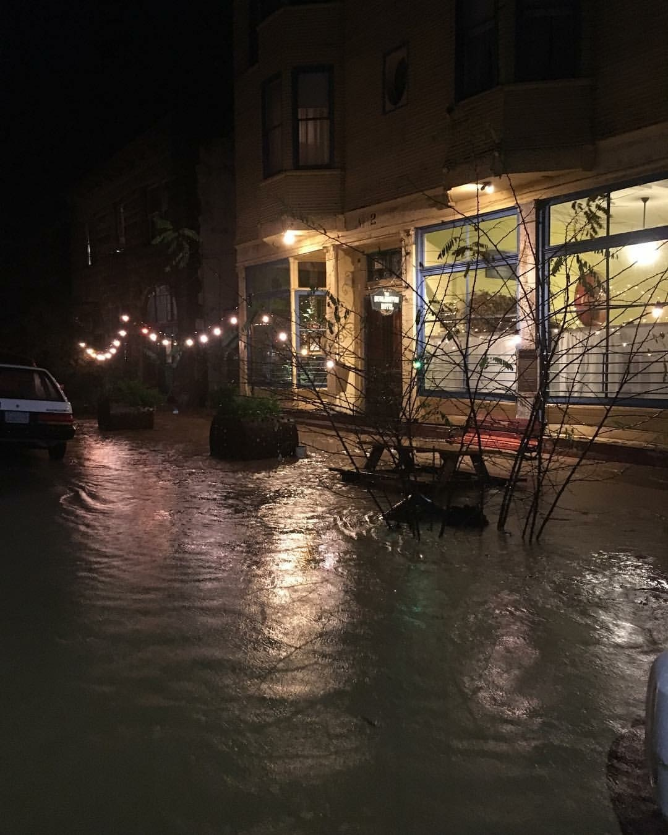
Photo by Earl Flewellen
January, February & March brought rain, rain and more rain. The Bull Valley Road House was flooded and McEwen Rd. was closed for several weeks due to mudslides and downed trees. All in all our little town held up quite well considering. Residents shoveled mud, cleaned out gutters and made the best of so many rainy days. The good news, no more drought, the hills are emerald green and the wildflowers are in full bloom.
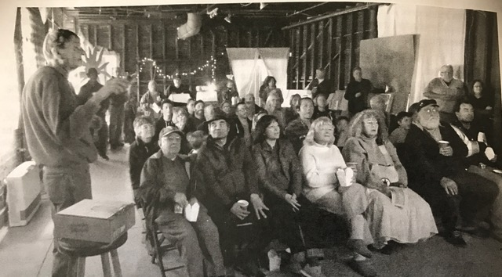
Photo by Dan Robertson
PCCS hosted a Crockett Community Foundation “Pop-Up” Sunday January 29th. It was a great opportunity for people to learn the history of our town and community. Lewis Stewart emceed and Dee Stewart worked the projector. The slide show included vintage photos and prior community events along with stories of the historic town. We will be showing the slide show again June 19th at 6:30pm, all are welcome.
FIELD SEMESTER ENVIRONMENTAL STUDY
On March 1st the first of many environmental meetings was held. BVAC and the Hyphae Group presented a slideshow with an overview of the three watershed areas above the lake, current water tributaries, site erosion, lake condition with regard to algae and silt, plant life (native, non-native and protected) and brief discussion regarding wildlife. This is the first of many meetings regarding the Lake property and the probable uses for the future. Future meeting dates to follow.
PCCS NEW BOARD ELECTIONS
The ballots are out and the nominees are: Ridge Greene, Jeff Wilson, Mitch Polzak, Ed Garon and Connie Cameron. Ballots must be received prior to April 17^{th.} and will be counted during the PCCS monthly meeting.
PORT COSTA GREEN CLEANUP
Monday, May 15, 2017 8 a.m. to Noon
PORT COSTA RESIDENTS ONLY
NO CONSTRUCTION MATERIALS ● NO PALM FRONDS
Eliminate fire safety hazards and beautify your yard! Bring your brush, tree trimmings, weeds and green waste to the Port Costa School ball field for chipping & mulching. Green waste may be dropped off ahead of time. The ball field gate at Reservoir Street will be open for two weeks, Saturday, April 29th to Sunday, May 14th. This is a free service provided by the Contra Costa County Public Works Department. Gloves, safety glasses and ear protection, ice water and sodas provided. Sponsored by the Port Costa Conservation Society. VOLUNTEERS WELCOME!

TOWN WIDE YARD SALE
SATURDAY. MAY 27
Now is the time to start rummaging through the house for those items you’ve been meaning to take to the Flea Market or nearest Goodwill store. The Port Costa Town Wide Yard Sale is set for Saturday, May 27th, 9 a.m. to 3 p.m., and anything goes: furniture, clothing, cookware, toys, books, you name it. All Port Costa residents are invited to set up in front of their residences. If your street is too narrow or steep (like Prospect Ave.), you may reserve a 10x10 space at the Port Costa School for a $30 donation to the school building restoration fund. To reserve a space, please request a form from portcostatownwide@yahoo.com. For all other town yard sale questions or offers to volunteer, please call Anne at (510) 691-0681.

4th of July Annual Port Costa Parade and Town Barbeque
For more information please contact Suzanne
(415)531-0432 - listatler@earthlink.net

PORT COSTA CAR SHOW AND BARBEQUE
SUNDAY AUGUST 13TH 10:00 am – 4:00 pm

Mark your calendars and check the PCCS website for more information.
(925)339-6085 - PortCostacarshow@yahoo.com

PORT COSTA CONSERVATION SOCIETY
P.O. BOX 36
PORT COSTA, CA 94569-0036
Nonprofit Org.
U.S. POSTAGE
PAID
Port Costa, CA 94569
Permit No. 3

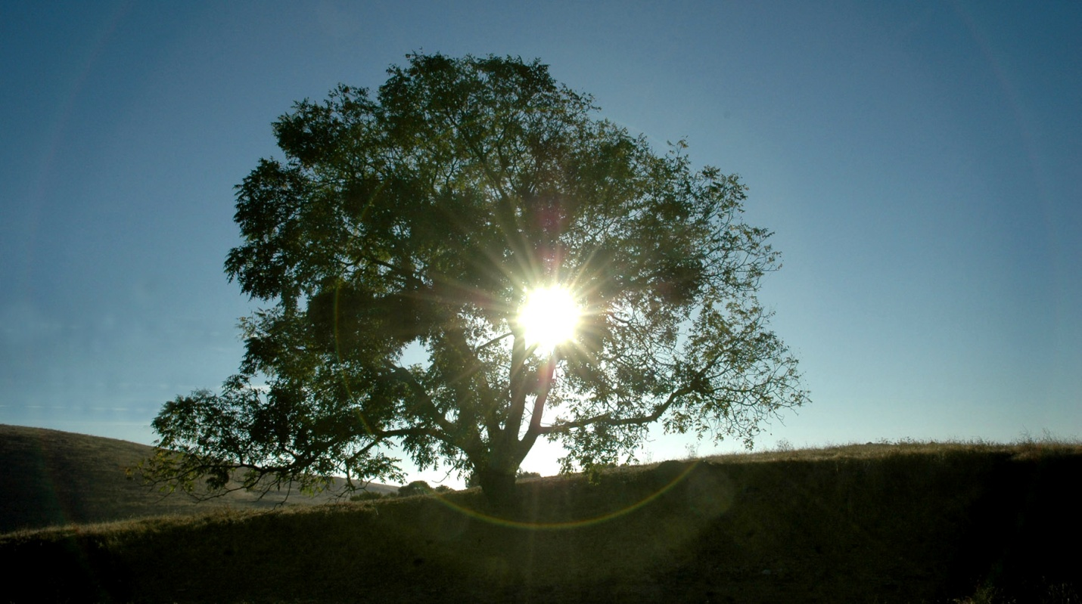

PORT COSTA GREEN CLEAN
Port Costa Residents Only - Monday, May 15, 2017 8 a.m. to Noon

